January 30th 2008

Athlete?

NSO?

Use of Finasteride and Cannabinoids (eg Marijuana) can be Doping

Dear «Recipient Name»

As an athlete registered with a National Sporting Organisation you have, as a condition of participation, a responsibility to be available for doping control sample collection processes in accordance with your sports Anti-Doping Policy.

Background
In accordance with the World Anti-Doping Code, your sport’s Anti-Doping Policy specifies that athletes must take full responsibility, in the context of anti-doping, for what they ingest and use. In recent times, ASADA has processed a number of Anti-Doping Rule Violations (ADRVs) after athletes’ samples were found to contain either (i) Finasteride; or (ii) Cannabinoids (eg. Marijuana)

ASADA has developed specific fact sheets on these substances to educate athletes and to assist them to comply with their anti-doping responsibilities. ASADA will also continue to work with National Sporting Organisations to educate athletes on those substances and methods that are included on the 2008 Prohibited List (See www.asada.gov.au ).

Finasteride is an anti-androgen commonly used as a treatment for baldness. It is a prohibited substance due to its potential for use as a masking agent for androgenic steroids. (See Finasteride Fact Sheet attached).
Before using this prohibited substance you must firstly contact your National Sporting Organisation to determine whether your sport’s anti-doping rules allow for Therapeutic Use Exemptions (TUEs) for prohibited substances. If so, you must strictly adhere to the approval procedures. This process may, in some circumstances involve consultation between your doctor and the Australian Sports Drug Medical Advisory Committee (ASDMAC) (See TUE Fact Sheet attached). In accordance with the 2008 Prohibited List an Anti-Doping Rule Violation (ADRV) may be issued to an athlete if evidence of the presence of finasteride is found in a sample provided by an athlete either in or out of competition.

Cannabinoids are one of the most commonly used illicit drugs in Australia and originate from the cannabis plant. (See Cannabinoids Fact Sheet attached). In accordance with the 2008 Prohibited List an Anti-Doping Rule Violation (ADRV) may be issued to an athlete if evidence of the presence of cannabinoids is found in a sample provided by an athlete in competition.
You must ensure that when you present to any competition that you are free of any prohibited substance. Cannabinoids are stored in the body’s fat cells and if used in the days, weeks or months before a competition, can lead to a positive test result.

Further Information

If you have any further questions in relation to the use of particular substances, or your responsibilities as an athlete more generally, information can be found on the ASADA website at www.asada.gov.au or alternatively you can call the ASADA Hotline on 1800 020 506.

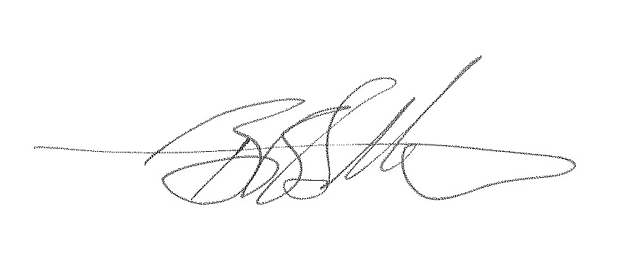
Yours sincerely

Benjamin Battisson
Stakeholder Manager

